**How to install banana pi**

**3 Banana pi BPI-M1+ (BPI-M1 Plus)**

**Banana Pi** - Credit Card Sized computing machine embedded with ARM processor running on Debian Linux OS. Pi Device capable of connecting digital devices to receive and send signals through 26 General Purpose Input/output PINS through voltage modulation of binary formats

Banana PI BPI-M1+ is the open source hardware platform, Banana PI BPI-M1+ is the dual core Android 4.4 product which more better than the Raspberry Pi. Banana Pi BPI-M1+ series run Android, Debian Linux, Ubuntu Linux, Raspberry Pi image and cubieboard image.

Banana PI BPI-M1+ hardware: 1Ghz ARM7 dual-core processor, 1GB DDR3 SDRAM, WIFI support onboard Banana PI BPI-M1+ with Gigabit ethernet port, SATA Socket. It can run with Android 4.4 smoothly.

The size of Banana PI BPI-M1+ like the credit card, it can easily run with the game it support 1080P high definition video output, the GPIO compatible with Raspberry Pi and can run raspbian image.

**BPI-M1+ hardware interface**

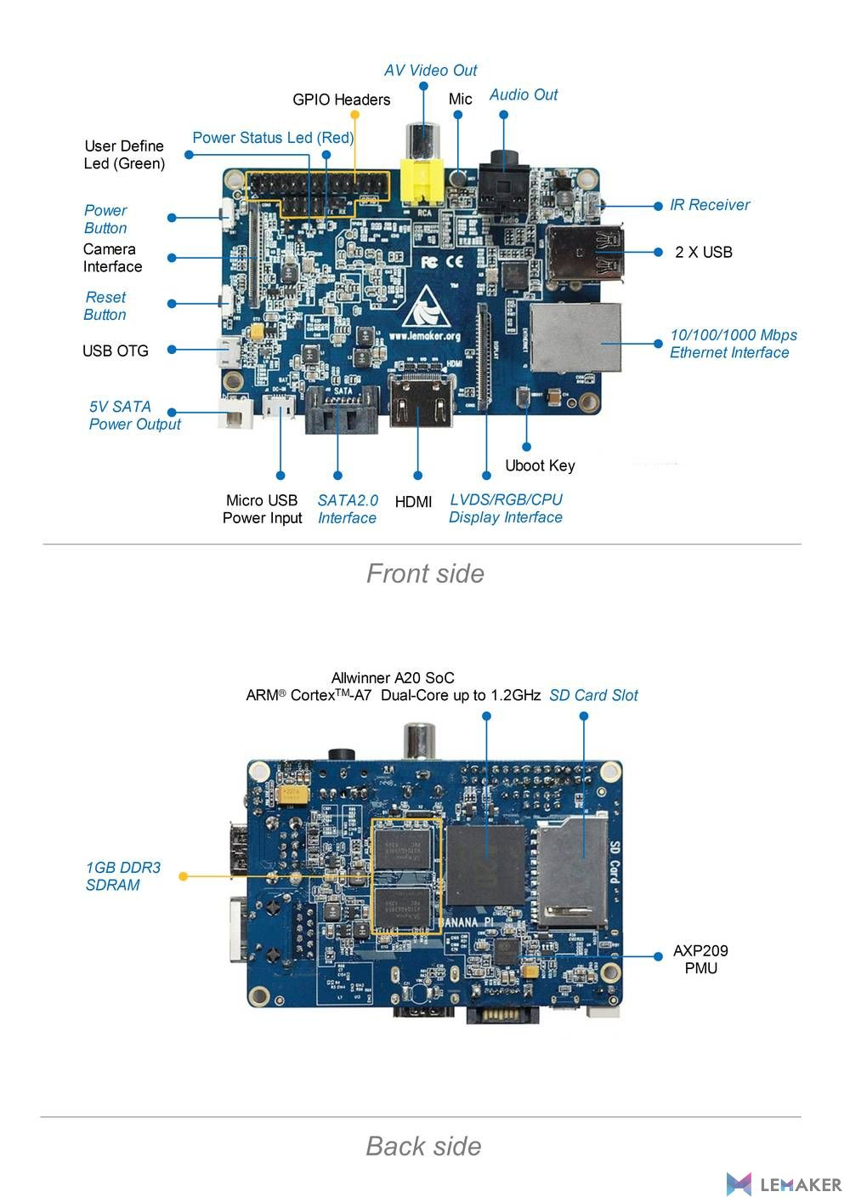**Fig: 2.3.1 Banana PI**

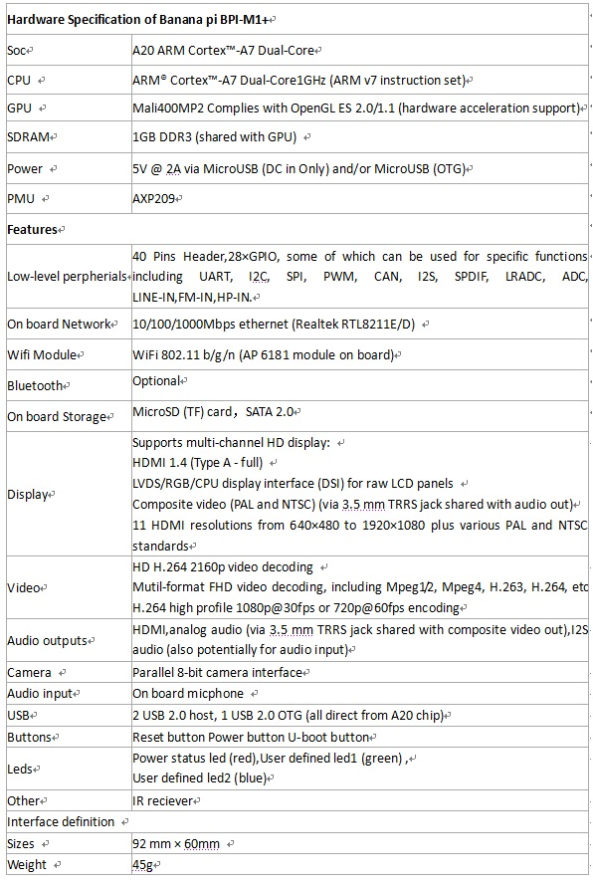

**Fig 2.3.2** :**BananaPI-M1+ hardware specifications**

**BPI-M1+ GPIO pin define**

**GPIO specification**

**Banana Pi 40-pin GPIO Banana Pi has a 40-pin GPIO header that matches th at of the Model B+ Raspberry Pi. Following is the Banana Pi GPIO**

**Pinout:**

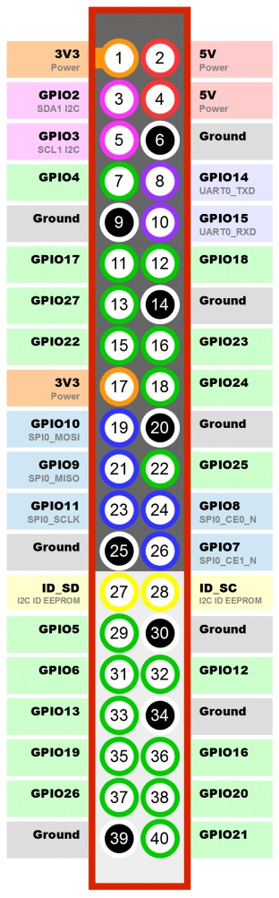

**Table: 2.3.3 Pin diagram**

|  |  |  |
| --- | --- | --- |
| GPIO Pin Name  CON3-P01  CON3-P02  CON3-P03  CON3-P04  CON3-P05  CON3-P06 | Default Function  VCC-3V3  VCC-DC  TWI2-SDA  VCC-DC  TWI2-SCK  GND | Function2：GPIO  PB21  PB20 |

**BPI-M1+ micro SD card slot**

BPI-M1+ have support a TF card slot. you can burn image to TF card ,and use it boot BPI-M1+ same as raspberry pi.

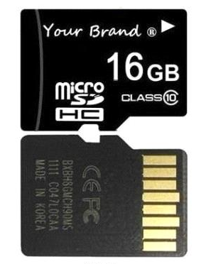

**Fig: 2.3.4 Micro SD card**

Note:

Support 8G 16G 32G 64G

Please choose class 10 TF card for banana pi.

**BPI-M1+ HDMI interface**

**BPI-M1+ has a standard HDMI 1.4 interface. so We can use HDMI-to-HDMI cable to connect BPI-M1 to the display monitor that has HDMI interface.**

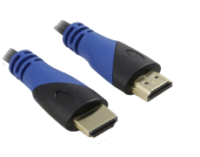

**Fig: 2.3.5 Cables**

**But If the display monitor doesn't have HDMI interface, only VGA or DVI port. We should use HDMI-to-VGA or HDMI-to-DVI cable to connect the BPI-M1+ to the display monitor.**

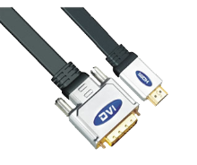

**Fig: 2.3.6 Cables**

**Note: if the HDMI-to-VGA/DVI cable is a bad quality cable, it will go wrong on the monitor display. Please choose a good quality cable for BPI-M1+**

**BPI-M1+ IR interface**

**BPI-M1+ support IR interface on board. You can use it as remote control.**

**How to use IR interface**

**Test on bananian image:**

**1**,install lirc

apt-get install lirc

apt-get install evtest

**2**,edit /etc/lirc/hardware.conf as below:

nano /etc/lirc/hardware.conf

# /etc/lirc/hardware.conf

#

# Arguments which will be used when launching lircd

LIRCD_ARGS="--uinput"

#Don't start lircmd even if there seems to be a good config file

#START_LIRCMD=false

#Don't start irexec, even if a good config file seems to exist.

#START_IREXEC=false

#Try to load appropriate kernel modules

LOAD_MODULES=true

# Run "lircd --driver=help" for a list of supported drivers.

DRIVER="UNCONFIGURED"

# usually /dev/lirc0 is the correct setting for systems using udev

DEVICE="/dev/input/event0"

MODULES="sunxi-ir"

ctrl+O save and ctrl+x exit.

**3**,test lirc

service lirc start

**4** test remote-control unit

Evtest

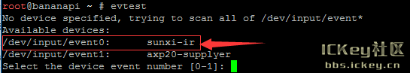

**Fig 2.3.7 Execution 1.**

Choose "0" must xunxi-ir

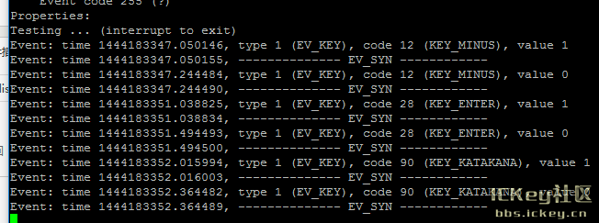

**Fig 2.3.7.1: Execution 2**

Please note: value 0 value 1

Press is: 1，unpress is:0

**BPI-M1+ USB interface:**

BPI-M1+ have two USB 2.0 interface on board.so you can connect Keyboard,mouse, USB camera and ... on BPI-M1+.

**HDMI:**

HDMI (High-Definition Multimedia Interface) is the first industry-supported, uncompressed, all-digital audio/video interface. HDMI provides an interface between any audio/video source, such as a set-top box, DVD player, and A/V receiver and an audio and/or video monitor, such as a digital television (DTV).

HDMI supports standard, enhanced, or high-definition video, plus multi-channel digital audio on a single cable. It transmits all ATSC HDTV standards and supports 8-channel digital audio, with bandwidth to spare to accommodate future enhancements and requirements.

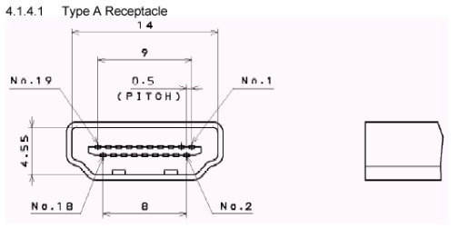

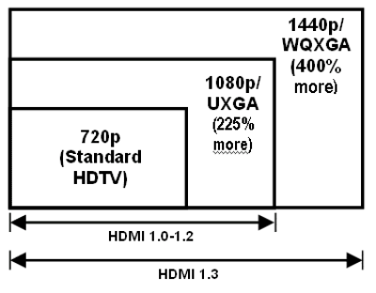

**Fig 2.3.8 HDMI**

**Jumper Wire:**

A jumper wire is a conducting wire used to transfer electrical signals between two points in a circuit. The wires can either be used to modify circuits or to diagnose problems within a circuit

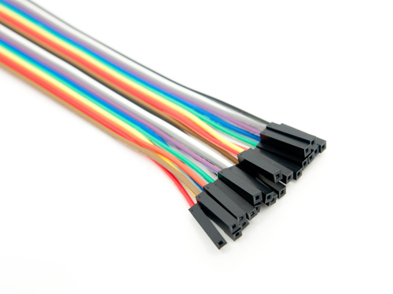

**Fig 2.3.9 Jumper wires**

**ULTRA SONIC SENSOR**

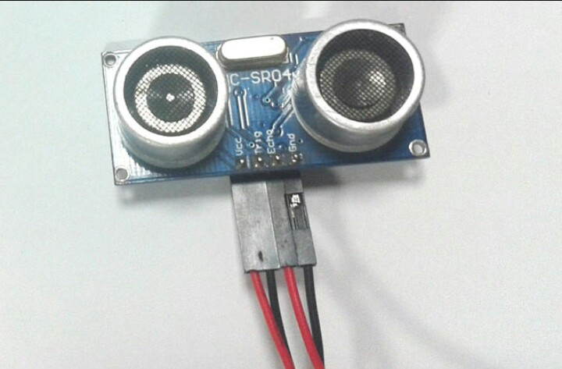

**Fig:2.3.10. UltraSonic Sensor**

An Ultrasonic sensor is a device that can measure the distance to an object by using sound waves. It measures distance by sending out a sound wave at a specific frequency and listening for that sound wave to bounce back. By recording the elapsed time between the sound wave being generated and the sound wave bouncing back, it is possible to calculate the distance between the sonar sensor and the object.

The accuracy of Ultrasonic sensor can be affected by the temperature and humidity of the air it is being used in. However, for these tutorials and almost any project you will be using these sensors in, this change in accuracy will be negligible.

It is important to understand that some objects might not be detected by ultrasonic sensors. This is because some objects are shaped or positioned in such a way that the sound wave bounces off the object, but are deflected away from the Ultrasonic sensor. It is also possible for the object to be too small to reflect enough of the sound wave back to the sensor to be detected. Other objects can absorb the sound wave all together (cloth, carpeting, etc), which means that there is no way for the sensor to detect them accurately. These are important factors to consider when designing and programming a robot using an ultrasonic sensor.

**Specifications**

* Echo Pulse Output
* 0V Ground

**Electric Parameter**

* Working Voltage DC 5 V
* Working Current 15mA
* Working Frequency 40Hz
* Max Range 4m
* Min Range 2cm
* Measuring Angle 15 degree
* Trigger Input Signal 10uS TTL pulse
* Echo Output Signal Input TTL lever signal and the range in
* proportion
* Dimension 45*20*15mm

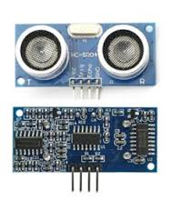

# Fig:2.3.11. Pin Configuration

1. VCC: 5V DC
2. GND: ground
3. DO: high/low output AO: analog output

**4 SOFTWARE REQUIREMENTS**

**Operating System** **:** Linux

**Languages** **:** Python

**5 HARDWARE REQUIREMENTS**

**BANANA PI BPI-M1+ – 1**

**ULTRASONIC SENSOR – 1**

**MICRO SD CARD – 4 GB**

**BPI-M1+ HDMI interface – 1**

**HDMI-to-VGA/DVI cable – 1**

**JUMPER WIRE – 4**